Unit 2: Forces and Energy
SDL: What is Force?
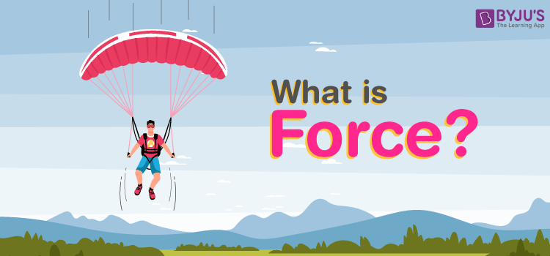
Push or pull of an object is considered a force. Push and pull come from the objects interacting with one another. Terms like stretch and squeeze can also be used to denote force.
In Physics, force is defined as: The push or pull on an object with mass causes it to change its velocity.
Force is an external agent capable of changing a body’s state of rest or motion. It has a magnitude and a direction. The direction towards which the force is applied is known as the direction of the force, and the application of force is the point where force is applied.
The Force can be measured using a spring balance. The SI unit of force is Newton(N).
Common symbols: | F
SI unit: | Newton
In SI base units: | kg.m/s²
Other units: | dyne, poundal, pound-force, kip, kilo pond
Derivations from other quantities: | F = m a

What are the Effects of Force?
In physics, motion is defined as the change in position with respect to time. In simpler words, motion refers to the movement of a body. Typically, motion can either be described as:
- Change in speed 2. Change in direction
The Force has different effects, and here are some of them.
Force can make a body that is at rest to move. It can stop a moving body or slow it down.
It can accelerate the speed of a moving body. It can also change the direction of a moving body along with its shape and size.

Types of Force
Force is a physical cause that can change an object’s state of motion or dimensions. There are two types of forces based on their applications:
- Contact Force
- Non-Contact Force

Contact Force
Forces that act on a body either directly or through a medium are called contact forces.
Examples of contact forces are:
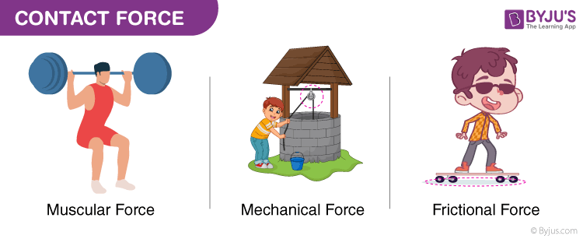
We can use the muscular force of animals like bullocks, horses, and camels to get the activities done. The frictional force is another type of contact force, which acts between a pair of a surface in contact and tends to oppose the motion of one surface over the other.

Non-Contact Force Forces that act through spaces without making direct contact with the body are called non-contact forces.
Examples of non-contact forces are:
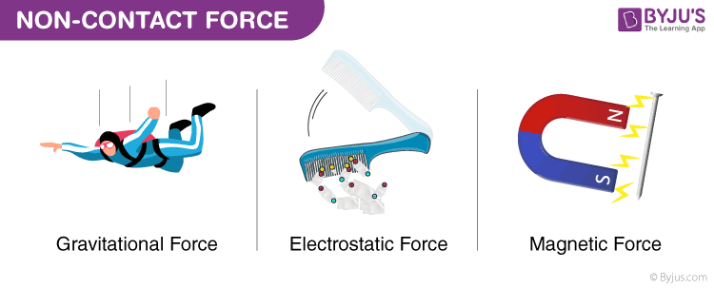
The force exerted by a magnet on other magnets is called magnetic force. Magnetic force and electrostatic force act on an object from a distance. That’s the reason they are non-contact forces. The strength of gravity is an attractive force that is exerted by the Earth on objects, which makes them fall to the land. The weight of a body is the force that is pulled by the earth towards the centre.

